Barbara McClintock
(1902 -1992)

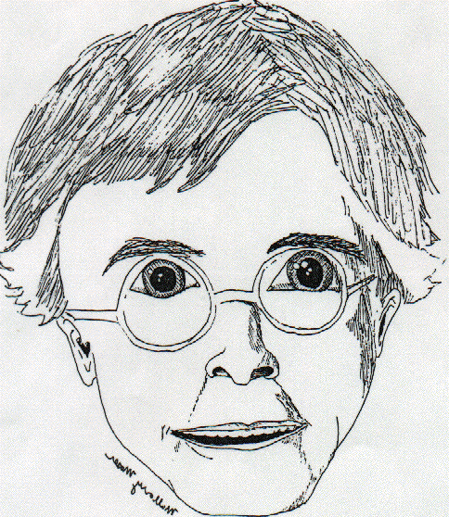 | Barbara McClintock entered the field of genetics when both were young. In her first work as a graduate student at Cornell University, she identified the members of each set of chromosome in corn (Zea maize). With Harriet Creighton, in 1931, she proved that the exchange of chromosomal material in meiosis is accompanied by a transfer of genetic material. She worked at Carnegie Institutes Laboratories in Cold Springs Harbor for forty years, studying how genes are controlled (move, signal one another, and turn on and off). In 1983 she received the Nobel Prize for physiology.  Artist: Mallory M.

